Visit of Debbie Weekes Bernard, Deputy Mayor of London – Citizens Advice Brent and Cost of Living Advice Project.

Background
As we prepare for winter cost of living pressures, London Citizens Advice and London Legal Support Trust (LLST) welcome the GLA announcement that the Cost of Living Advice Partnership funding has been extended for a year and increased, this a huge boost for advice agencies like Citizens Advice Brent that are struggling to cope with demand.
Supported by GLA, through this project the London Citizens Advice network works alongside the network of London Legal Support Trust Centres of Excellence including London Law Centres to enhance advice services in London. This project deploy the resources of London advice agencies in a collaborative way, increasing the availability of advisers, recruiting new posts, and working in partnership with community organisations to support Londoners who are facing hardship. 19 local Citizens Advice offices, 18 Centres of Excellence Advice agencies and law centres and 3 community organisations are supported through the partnership. A wider range of community groups are also trained in ‘Advice First Aid’.
The London Citizens Advice network have supported over 13,000 clients since the launch of the project last year, of which over have 800 been Brent clients. The Project funds one full time adviser post for Citizens Advice Brent, and the Brent team work closely with other GLA funded Citizens Advice partners in North and West London, including Citizens Advice Hounslow, Citizens Advice Hammersmith and Fulham, Citizens Advice Harrow. They also work in collaboration with other GLA funded project partners via the London Legal Support Trust, including Hammersmith and Fulham Law Centre, Harrow Law Centre, Ealing Law Centre, and Camden Community Law Centre, whose drop-in legal clinics over the last year have reached over 250 clients in Brent.
11.00 Arrive

11.05 Meet the teams (see next page)

11.10 Tour of Brent Office

11.30 Discussion with advice staff, partners etc. This will include a video link with other partners.

11.50 Photos

Refreshments

Possible visit to Willesden Library (5 minute walk away) to talk to outreach Adviser.

Citizens Advice Brent team
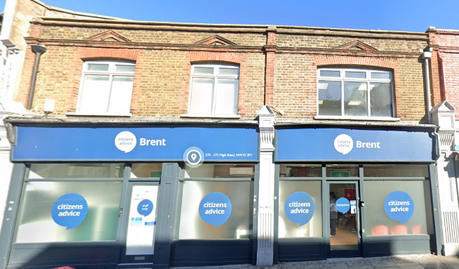
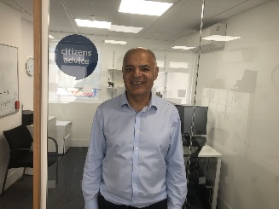
Raj Kapoor, Chief Executive Officer, Citizens Advice Brent (CAB)
Raj started with CAB on 5th June 2023. Raj was previously employed as the CEO of Age Exchange, a reminiscence arts charity based in Blackheath, which runs services for people affected by dementia.. Raj has over 23 years’ experience working in the areas of mental health, social housing, alcohol harm, dementia and now advice. He is married with a 15 year old daughter. Raj is a member of Citizens Advice London Steering Group.

Adio Garbadeen, Advice & Quality Manager
Adio commenced employment with Citizens Advice Brent in 2004. A resident of Brent, Adio is married with three sons. Adio is LLM qualified, an accredited Money Adviser, DRO intermediary and intermediary for the government’s breathing space scheme. As part of his role Adio enjoys empowering clients, developing staff, helping clients to deal with cost of living issues and helping people to achieve positive financial outcomes.

London Citizens Advice Team

James Sandbach, London Development Manager.
James was appointed in late 2021 to lead development of Pan-London projects - a new post and initiative to encourage Pan-London working across advice partners, build links with London wide stakeholders, and drive London policy and campaigns. Previously he was Director of Policy and External Affairs for LawWorks, and prior to that with the Legal Action Group where he worked for Lord Low’s Commission on social welfare advice services. He worked for over 10 years as justice lead for Citizens Advice policy team, and has held other policy roles in the voluntary sector including at Mind and Action on Hearing Loss (formerly RNID), has been called to the Bar and holds a doctorate in conflict resolution. James is also a Trustee of the Advice Services Alliance.

Michelle Rose, Project Manager
Michelle was appointed as Project Manager in September 2022 following previous roles at Citizens Advice Wandsworth as a Service Manager for Projects and Generalist Adviser. Michelle started her Citizens Advice career as a volunteer adviser in 2016. As Project Manager, Michelle provides support to the London Citizens Advice delivery partners of the Cost of Living project, delivers Advice First Aid training and collating and reporting delivery data.

Joanna Cain, CEO Citizens Advice Westminster
Joanna has chaired the London Citizens Advice Chief Officers Forum for the past year, and is member of the London Sterring Group. She joined Citizens Advice Westminster in 2021 from a background in adult education and the third sector.

London Legal Support Trust

Rosa Coleman
Rosa is the Head of Sector Support and Grants and oversees LLST’s grant-making and sector support programmes which aim to empower a more robust, sustainable specialist free legal advice sector. She first volunteered at LLST in 2013 and has been with the organisation full-time since 2018. Rosa has been project managing the cost of living project and sharing learning from this partnership model with other networks and funders.

